LAB SHEET 5

Name: Aadithyan Raju

Roll No: AM.EN.U4CSE21301

Q1.

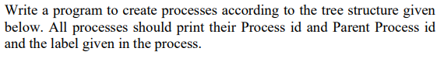

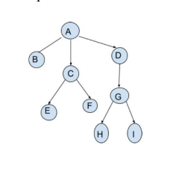

CODE:

#include <stdio.h>

#include <stdlib.h>

#include <unistd.h>

#include <sys/wait.h>

int main() {

    // Create process A

    pid_t pid_a = getpid();

    printf("Process A: pid=%d, ppid=%d, label=A\n", pid_a, getppid());

    // Create process B

    pid_t pid_b = fork();

    if (pid_b == 0) {

        printf("Process B: pid=%d, ppid=%d, label=B\n", getpid(), getppid());

        exit(0);

    }

    // Create process C

    pid_t pid_c = fork();

    if (pid_c == 0) {

        printf("Process C: pid=%d, ppid=%d, label=C\n", getpid(), getppid());

        // Create process E

        pid_t pid_e = fork();

        if (pid_e == 0) {

            printf("Process E: pid=%d, ppid=%d, label=E\n", getpid(), getppid());

            exit(0);

        }

        // Create process F

        pid_t pid_f = fork();

        if (pid_f == 0) {

            printf("Process F: pid=%d, ppid=%d, label=F\n", getpid(), getppid());

            exit(0);

        }

        exit(0);

    }

    // Create process D

    pid_t pid_d = fork();

    if (pid_d == 0) {

        printf("Process D: pid=%d, ppid=%d, label=D\n", getpid(), getppid());

        // Create process G

        pid_t pid_g = fork();

        if (pid_g == 0) {

            printf("Process G: pid=%d, ppid=%d, label=G\n", getpid(), getppid());

            // Create process H

            pid_t pid_h = fork();

            if (pid_h == 0) {

                printf("Process H: pid=%d, ppid=%d, label=H\n", getpid(), getppid());

                exit(0);

            }

            // Create process I

            pid_t pid_i = fork();

            if (pid_i == 0) {

                printf("Process I: pid=%d, ppid=%d, label=I\n", getpid(), getppid());

                exit(0);

            }

            exit(0);

        }

        exit(0);

    }

    // Wait for all child processes to finish

    int status;

    wait(&status);

    wait(&status);

    wait(&status);

    wait(&status);

    wait(&status);

    wait(&status);

    return 0;

}

OUTPUT:

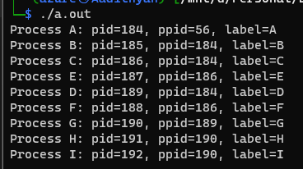

Q2.

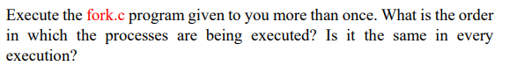

Order: Child then Parent

Same: Yes it is the same.

Q3.



Code:

#include <stdio.h>

#include <sys/types.h>

#include <sys/wait.h>

#include <unistd.h>

#define MAX_COUNT 5

void  ChildProcess(void);                /* child process prototype  */

void  ParentProcess(void);               /* parent process prototype */

void  main(void)

{

    pid_t  pid;

    pid = vfork();

    if (pid == 0) ChildProcess();

    else ParentProcess();

    int status;

    wait(&status);

}

void  ChildProcess(void)

{

    int   i;

    for (i = 1; i <= MAX_COUNT; i++) printf("   This line is from child, value = %d\n", i);

    printf("   *** Child process is done ***\n");

}

void  ParentProcess(void)

{

    int   i;

    for (i = 1; i <= MAX_COUNT; i++) printf("This line is from parent, value = %d\n", i);

    printf("*** Parent is done ***\n");

}

OUTPUT:

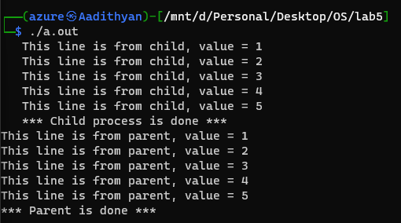

Q4.



#include <stdio.h>

#include <stdlib.h>

#include <unistd.h>

#include <sys/wait.h>

#define PI 3.1415

void circle() {

    float r, a, p;

    printf("Enter r of the circle: ");

    scanf("%f", &r);

    a = PI * r * r;

    p = 2 * PI * r;

    printf("Area of the circle = %f\n", a);

    printf("Perimeter of the circle = %f\n", p);

}

void square() {

    float s, a, p;

    printf("Enter side length of the square: ");

    scanf("%f", &s);

    a = s * s;

    p = 4 * s;

    printf("Area of the square = %f\n", a);

    printf("Perimeter of the square = %f\n", p);

}

int main() {

    // Create process for circle

    pid_t pid_c = fork();

    if (pid_c == 0) {

        circle();

        exit(0);

    } // Wait

    int status;

    waitpid(pid_c, &status, 0);

    // Create process for square

    pid_t pid_s = fork();

    if (pid_s == 0) {

        square();

        exit(0);

    }

    // Wait

    waitpid(pid_s, &status, 0);

    return 0;

}

OUTPUT:

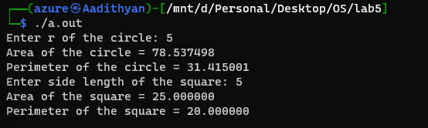

Q5:

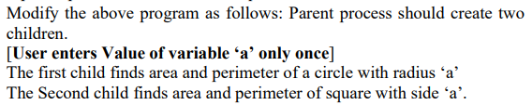

CODE:

#include <stdio.h>

#include <stdlib.h>

#include <unistd.h>

#include <sys/wait.h>

#define PI 3.1415

void circle(float r) {

    float a, p;

    a = PI * r * r;

    p = 2 * PI * r;

    printf("Area of the circle = %.2f\n", a);

    printf("Perimeter of the circle = %.2f\n", p);

}

void square(float s) {

    float a, p;

    a = s * s;

    p = 4 * s;

    printf("Area of the square = %.2f\n", a);

    printf("Perimeter of the square = %.2f\n", p);

}

int main() {

    // Create process for circle

    float a;

    printf("Enter a: ");

    scanf("%f", &a);

    pid_t pid_c = fork();

    if (pid_c == 0) {

        circle(a);

        exit(0);

    }

    // Create process for square

    pid_t pid_s = fork();

    if (pid_s == 0) {

        square(a);

        exit(0);

    }

    sleep(1);

    return 0;

}

OUTPUT

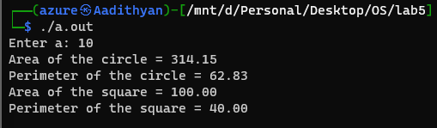

Q6.



#include <stdio.h>

#include <stdlib.h>

#include <unistd.h>

#include <sys/wait.h>

#define PI 3.1415

void circle(float r) {

    float a, p;

    a = PI * r * r;

    p = 2 * PI * r;

    printf("Area of the circle = %.2f\n", a);

    printf("Perimeter of the circle = %.2f\n", p);

}

void square(float s) {

    float a, p;

    a = s * s;

    p = 4 * s;

    printf("Area of the square = %.2f\n", a);

    printf("Perimeter of the square = %.2f\n", p);

}

int main() {

    // Create process for circle

    float a;

    printf("Enter a: ");

    scanf("%f", &a);

    pid_t pid_c = fork();

    if (pid_c == 0) {

        circle(a);

        exit(0);

    } // Wait

    int status;

    waitpid(pid_c, &status, 0);

    // Create process for square

    pid_t pid_s = fork();

    if (pid_s == 0) {

        square(a);

        exit(0);

    }

    return 0;

}

OUTPUT:

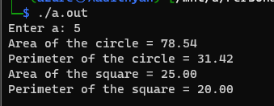

Q7.

CODE:

#include <stdio.h>

#include <stdlib.h>

#include <unistd.h>

#include <sys/wait.h>

#define PI 3.1415

void circle(float r) {

    float a, p;

    a = PI * r * r;

    p = 2 * PI * r;

    printf("Area of the circle = %.2f\n", a);

    printf("Perimeter of the circle = %.2f\n", p);

}

void square(float s) {

    float a, p;

    a = s * s;

    p = 4 * s;

    printf("Area of the square = %.2f\n", a);

    printf("Perimeter of the square = %.2f\n", p);

}

int main() {

    // Create process for circle

    float a;

    printf("Enter a: ");

    scanf("%f", &a);

    pid_t pid_c = fork();

    if (pid_c == 0) {

        circle(a);

        exit(0);

    }

    int status;

    waitpid(pid_c, &status, 0);

    // Create process for square

    pid_t pid_s = fork();

    if (pid_s == 0) {

        square(a);

        exit(0);

    }

    waitpid(pid_s, &status, 0);

    return 0;

}

OUTPUT:

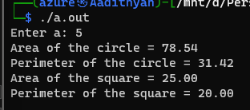

Q8.

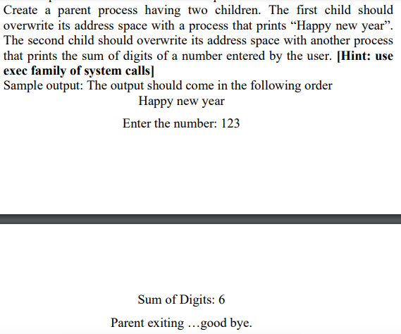

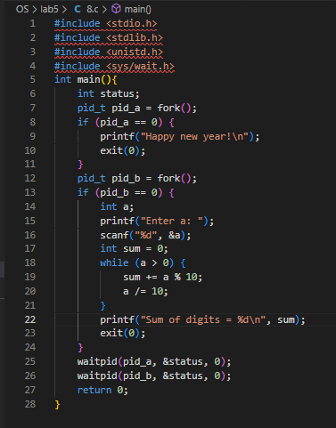

OUTPUT:

